**H1 2023 Strategic Business Review**

**1. Executive Summary**

This report provides a strategic overview of the company's performance in the first half of 2023 (H1), highlighting key metrics, sales performance, competitive positioning, and market opportunities. The analysis is based on sales, product, customer, and market data up to June 30, 2023. The company remains a dominant player in the European pharmaceutical commercialization sector, with strong revenue performance and opportunities for further growth.

Dashboard Page 1

At first glance, the dashboard provides a clear overview of the company's performance. Q1 shows a slow start, with figures trailing behind the previous year. However, this was anticipated by projections. Due to Covid-19 **many healthcare providers, hospitals, and pharmacies had overstocked** pharmaceutical products in 2022, leading to a temporary decline in new orders as they focused on depleting existing inventory.

Despite this initial slowdown, the sales team regained momentum toward the end of Q1 and into the beginning of the new financial year, reflecting a strong recovery in demand.

**2. Financial Performance Overview**

* **Total Revenue:** $644,087,920.80
* **Total Margin:** $214,047,491.70
* **Total Units Sold:** 1,135,835
* **Profit Margin:** 33%
* **Achieved AOP:** 65.4%

**Key Takeaways:**

* **Recovery Validates Market Resilience**  
  The initial slowdown in Q1, driven by inventory destocking, aligns with forecasts. However, the strong rebound in Q2 suggests that demand fundamentals remain intact, reaffirming the company's market positioning.
* **Revenue Performance is Solid, But Market Share Gains Are Uneven**  
  While overall revenue has remained strong, performance varies by region and product line. Some segments are growing faster than others, highlighting areas for targeted commercial efforts.
* **Sales Efficiency is Improving Despite a Decline in Order Volume**  
  The drop in total orders (-15.3%) is offset by a higher average deal size (+14.8%), indicating stronger negotiation leverage and product positioning in high-value deals (suggested further analysis).

**3. Revenue & Profitability Drivers**

**Top 3 Revenue-Generating Products**

* **Zanamivir:** $15,358,554
* **Amoxiril:** $15,025,408
* **Rituximab:** $14,249,538

**Strategic Considerations:**

* **Capitalize on High-Performing Products to Sustain Momentum**  
  The top-selling products are driving a significant share of revenue. Ensuring supply chain stability and reinforcing their market penetration should be a priority.
* **Address Underperforming Segments with More Targeted Actions**  
  The gap between teams in meeting their AOP targets suggests room for localized commercial strategies rather than a one-size-fits-all approach. Tailoring incentives and outreach in weaker regions could drive additional growth.
* **Leverage Market Intelligence to Optimize Pricing & Bundling**  
  The increasing average deal size presents an opportunity to refine pricing strategies further and introduce bundled offerings to enhance cross-product adoption.
* **Ensure Agile Inventory Management to Prevent Supply Bottlenecks**  
  The Q1 destocking effect underscores the importance of anticipatory inventory planning. Strengthening demand forecasting and real-time stock allocation will help mitigate future slowdowns.

**4. Sales Team Performance**

**Top Sales Team by Revenue**

* **Team TTD:** $134,786,887.55

**Key Observations:**

* Team TTD outperformed other teams significantly, contributing a substantial share of total revenue.
* Performance gaps exist among other teams, indicating potential inefficiencies or disparities in market approach.

**Strategic Implications:**

* Scale Proven Strategies: Identify the specific tactics, customer engagement models, and product focus areas that contributed to TTD's success and replicate best practices across lower-performing teams.
* Deep-Dive into Sales Productivity Metrics: Analyse win rates, sales cycle length, and conversion rates to determine where improvements can be made to streamline efforts.
* Optimize Sales Enablement & AI Integration: Assess whether AI-driven lead scoring, predictive analytics, and targeted engagement could improve overall sales effectiveness, ensuring that sales teams prioritize high-potential opportunities.

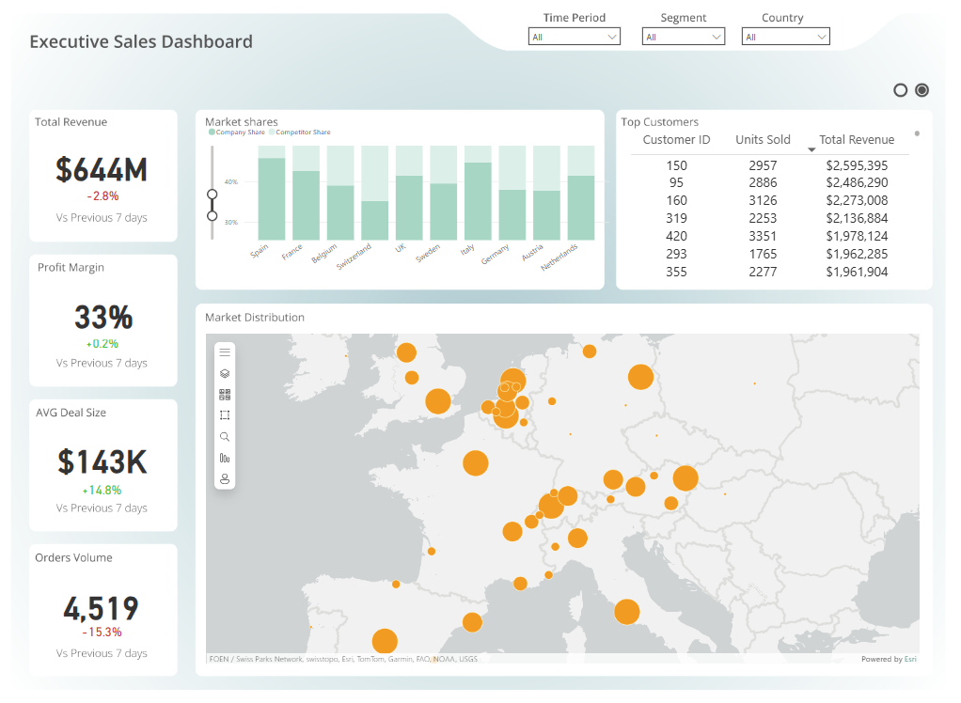

Dashboard Page 2

**5. High-Value Customers**

**Top 3 Customers by Revenue**

* **Customer 150:** $2,595,395
* **Customer 95:** $2,486,290
* **Customer 160:** $2,273,008

**Strategic Recommendations:**

* Strengthen Top Customer Retention with Tailored Account Strategies
  + Implement high-touch engagement programs for key accounts to enhance loyalty and prevent competitor penetration.
  + Leverage historical purchasing patterns to anticipate future demand and proactively offer tailored solutions.
* **Drive Upselling & Expansion via STP (Segmentation, Targeting, Positioning)**
  + Identify cross-sell and upsell opportunities based on product adoption trends within these accounts.
  + Introduce exclusive service tiers, volume-based discounts, or early-access to new product lines to maximize account value.
* **Enhance Customer Experience & Incentives**
  + Offer dedicated relationship managers or specialized support for top-tier customers.
  + Introduce strategic long-term contracts or rebates to ensure ongoing engagement and commitment.

**6. Market Trends & Competitive Positioning**

The company maintains a strong presence in key European markets, though competitive dynamics vary significantly. Certain regions require defensive strategies, while others present opportunities for targeted expansion.

**Market-Specific Strategic Insights**

1. **Germany & Switzerland: Market Recovery Priorities**
   * Germany (36.06% share) and Switzerland (36.55%) face high competitive pressure.
   * **Action Plan:**
     + Reassess pricing strategies to improve cost competitiveness without compromising margins.
     + Strengthen distributor partnerships and refine localized go-to-market execution.
     + Implement differentiated value propositions (e.g., faster fulfilment, personalized support).
2. **Spain & Italy: Strongholds for Expansion**
   * Spain (46.42%) and Italy (44.16%) remain strong revenue drivers with growth potential.
   * **Action Plan:**
     + Expand local salesforce coverage to penetrate untapped customer segments.
     + Invest in localized marketing initiatives to reinforce brand dominance.
     + Strengthen relationships with key healthcare providers and government buyers.
3. **Belgium & France: High-Value Growth Markets**
   * **Belgium (40.40%) and France (41.50%) present substantial opportunities for further market penetration.**
   * **Action Plan:**
     + Refine segmentation strategies to focus on high-value customer acquisition.
     + Enhance commercial execution by boosting sales team effectiveness in these regions.
     + Introduce tailored incentive structures for distributors to drive higher sell-through rates.
4. **Stable Markets: UK, Netherlands, Austria & Sweden**
   * Performance in these regions remains steady, with moderate growth potential.
   * **Action Plan:**
     + Maintain and fine-tune customer retention programs.
     + Optimize logistics and distribution to reduce lead times and increase service levels.
     + Identify small-scale operational improvements to incrementally increase market share.

**7. Strategic Recommendations**

**Short-Term Priorities (Next 3-6 Months)**

1. **Market-Specific Growth Acceleration**
   * Deploy localized expansion strategies in Belgium, France, Spain, and Italy while refining positioning in Germany & Switzerland.
2. **Customer Retention & High-Value Growth**
   * Implement a high-engagement model for top-tier customers, ensuring proactive relationship management.
3. **Product & Pricing Strategy Optimization**
   * Ensure top-performing products remain competitive by dynamically adjusting pricing and inventory distribution based on real-time market insights.